Recruitment Script
Parents and Influential Kin

Good Morning/Afternoon,

My name is ___________, and I am working on a project with the PROJECT NAME AND AFFILIATION. I would like to invite you to participate in a research study that aims to understand how communities and health services support young parents in this district. You are being invited to participate as we believe that you will have valuable insights to share and we will use your answers and answers of others we are meeting to improve use of services by young parents in this District. First, let me ask you a few questions.

“I’d like to speak with you for a few minutes. Do you have a few minutes to listen now?”
[IF NO] “May I look for you another time to talk?”
[IF NO] “Okay, thank you for your time. We will not continue. Have a good day!”
[IF YES] “Thank you. What is a time that is convenient for you?”
Interviewer arranges a meeting with the individual and follows up. At that meeting, interviewer begins with the next step below.
[IF YES]: “Thank you! Let me tell you more about what we would like to do.”

If you agree to participate, a researcher will contact you to invite you to participate in a group discussion with about 8 other people, and answer some questions. This discussion will take about one hour. You do not have to participate.

The conversation about your experiences will be confidential and your individual responses will not be shared with anyone. Anything produced using information you share will not include your name or any information giving away your identity. If you do participate, we will reimburse you 2 USD for your transportation costs.

“Do you have any questions for me?” “Are you interested in participating in this study?”
[IF NO]: “Okay, thank you for your time. Have a good day!”
[IF YES]: “Okay, I will collect your contact information and share it with the researchers.”

** Interviewer – If participant expresses interest, proceed to collect contact information. If not, thank the individual for their time and visit the next potential respondent. Answer any questions before collecting contact information. **

Written Consent
FGD Tool #4– Parents and Influential Kin of Young Parents

Hello, my name is______. Let me allow my colleague to introduce himself/herself. My colleague and I would like to talk to you about care and health services for young parents. We are working to understand which people and community institutions influence young parents as they plan to have children, become pregnant, and deliver in this District. This is a research study being conducted by PROJECT NAME AND AFFILIATION. We would like to ask you to help answer our questions. We would like to ask you questions because you have children or family members who are young parents and have given then advice and counsel. We believe that you have valuable insights to share and we will use your answers and answers of others we are meeting to improve use of services by young parents in this District. We are interviewing others, such as village elders, health center staff, as well as young women and men who are first-time parents. During the discussion, you will be asked questions about how young parents decide to seek and use health services and what barriers exist. You will be asked to describe your personal experiences with supporting young parents through pregnancy and delivery and possibly use of methods to space births.

You do not have to help, it is your choice. If you say yes, we will ask you to speak with us in a group of about 8 other people, and answer some questions. During our discussion, we will take notes and make an audio recording. It will take about one hour. It is possible that some questions may be uncomfortable to answer. That is not our intention. You do not have to answer all the questions. Also, you may stop participating in the discussion at any time. There is no penalty if you choose to stop answering questions, and it will not affect your access to health services or your employment.

We will ask all group members to keep the information shared within the group confidential. There is a chance that someone outside the study will see your information. But we will do our best to keep the information you tell us confidential and secure. We will keep the audio recording tapes in a locked cabinet. Your name will not be included in any reports or notes that we write based on this information. Any record of your name will be destroyed. When the study is completed, we will destroy the tapes.

You will receive no personal benefit from answering our questions. We will not pay you to help us. There is no payment, and we do appreciate your time. We will reimburse you 2 USD for travel costs.

Do you have any questions? You may contact PRINCIPAL INVESTIGATOR NAME AND CONTACT about your questions or concerns with this work.

Thank you for your consideration. May I begin?

Certificate of Consent - Participant
I have read or have been read the above considerations regarding my participation in the study. I have been given a chance to ask questions and the questions have been answered to my satisfaction.

I understand that my records will be kept private and that I can stop the discussion at any time. I also understand that my decision to stop the discussion will not affect me adversely.

I agree to this discussion.

Signature of participant ____________________________

If oral consent, signature of interviewer ___________________ Date ________________

Investigator’s Statement
I, the undersigned, have explained to the participant the procedures to be followed in the study and the risks and benefits involved. I have also provided my mobile number so that he/she may contact me at any time if required.

Name of the interviewer _____________________________

Signature of the interviewer _______________________ Date _____________________

A copy of this consent form has been provided to the participant (if asked for). (Initialled by the discussant)

Formative Research on First Time/Young Mothers/Parents
FGD #4: FGD Guide for Parents and Influential Kin of Young Parents
Face Sheet

Group Type (circle): [ Adults, age 15-19 ] [ Adults, age 20-24 ]

Group Discussion Code: |___||___||___||___|

Village: ________________________________________________________________________

District: _______________________________________________________________________

Discussion by: _________________________________________________________________

Date of Discussion: [___|___] [___|___] [___|___|___|___]
D D M M Y Y Y Y

Time Discussion Began: [___|___]: [___|___]
Hour Minute

Time Discussion Ended: [___|___] : [___|___]
Hour Minute

Results of Discussion: Completed 1
Partially Completed 2
Refused 3

Name and Signature of Supervisor ___________________________________________

Date Checked: [___|___] [___|___] [___|___|___|___]
D D M M Y Y Y Y

Participants
Respondents (who may be male, female, or a mixed group) should include 5 to 8 individuals.

Required Preparatory Steps
- Identification of categories of people who influence young parents through the analysis of interviews conducted with young parents who use SRH services.
- Recruitment of 5-8 parents and kin who influence young parents.
- For all participants in the group discussion, consent is mandatory.
- Eligibility should be verified and socio-demographic information should be collected from participants on an individual basis.

Necessary Tools and Materials
- One room with sufficient space, with a sufficient number of chairs, that is well-ventilated and quiet
- FGD guide
- Two dictaphones with batteries (and back-up batteries)
- One notebook and one pen

Process
- The group should sit in a circle.
- The facilitator should ensure good participation from all respondents. The associate facilitator should take notes.
- The group discussion should be conducted as a conversation, with each question flowing from the answer to the previous one. Each of the topics should be covered during the discussion. The questions are there as examples. These are the types of information that is to be collected, but how the questions are asked will depend on how the conversation flows. The questions are not meant to limit the discussion, but rather keep the discussant on track.

If participants have specific questions about SRH, responses to these questions should wait until the end of the discussion.

At the end of the discussion, the data collectors should thank participants for their participation and reimburse for transportation expenses.

Information Sought From Parents and Influential Kin
- Roles and responsibilities of the family in supporting young parents
- Use of SRH services by young parents

Section 1: Demographic Information
Resp | Name (Code) | Age (Years) | Education | Occupation | Marital status
A
B
C
D
E
F
G
H
I
J

Code:
Education | 0: No education / 1: Primary / 2: Secondary / 3: University / 4: Vocational training / 96: Other (Specify)
Occupation | 1: Student / 2: Service / 3: Business / 4: Farming / 96: Other (Specify)
Marital status | 1: Unmarried / 2: Married or in Union / 3: Separated / 96: Other (Specify)

Tool FGD #4: FGD Guide For Parents And Influential Kin Of First-Time/Young Parents

Introduction of Group Members
Could you please go around the circle and share your name and village you come from?

Family Roles and Responsibilities to Support First Time Parents
- How old were you when you had your first child? Who were the people who supported you as you moved from pregnancy to delivery and then becoming a parent? Did you feel prepared for your new responsibilities?
- At what age was your child and his/her partner when they first became pregnant? How does it feel to be the parent or relative of a first-time mother or father and starting a family?
- Have you spent time talking with your child about becoming a mother or father? What kinds of things do you talk about? [Probe whether both women and men are talking with their children and whether they talk about different things.]
- Beside talking and offering advice, are there other things you have done to support your child during their first pregnancy and delivery? Can you give examples? [Probe whether men and women provide support and how support differs by sex.]
- In your opinion, when is the ideal time to have your first child? Why?
- Did you speak with your child about the ideal time to have their first child? What kinds of things did you talk about? [Probe whether men and women provide advice and if advice differs by sex.]
- In your opinion, when is the ideal time to have the second child? Why?
- Have you ever spoken to your child about child spacing? About using FP methods? What kinds of things do/did you talk about? [Probe whether men and women provide advice and if advice differs by sex.]
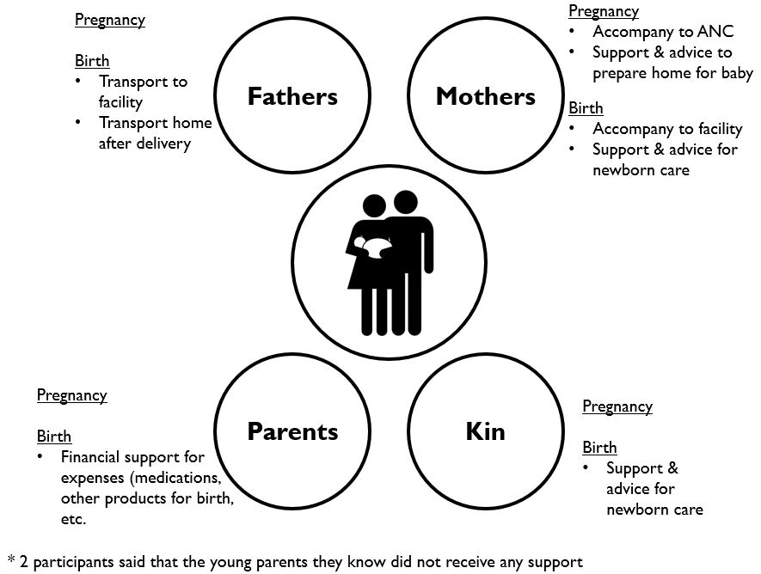
- Explain: In the middle of this sheet of paper is a couple who are first time parents at age 18. Surrounding them are four circles that represent fathers, mothers, and kin. As you discuss, I will write next to each of the 4 circles what the group says are the main responsibilities of different family members in supporting their children as they move from pregnancy to childbirth to becoming first-time/young parents. [Keep adding responsibilities until there are no new ideas.]
Figure 1: Example partial influence map from focus group discussions with family and kin

Ask: Who else has responsibilities in this community to support your children as they become first-time/young parents? What are their main responsibilities? Let us add them to this paper, putting them into new circles.
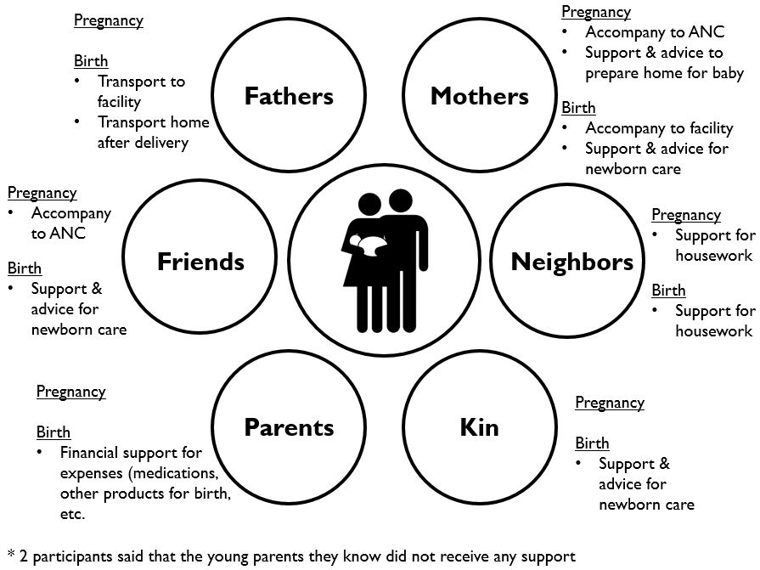
Figure 2: Example partial influence map from focus group discussions with family and kin

Say: Now that we have completed this, can you say if the different groups link to support young people as they become parents? We can draw lines that show the linkages. How are these different people linked?

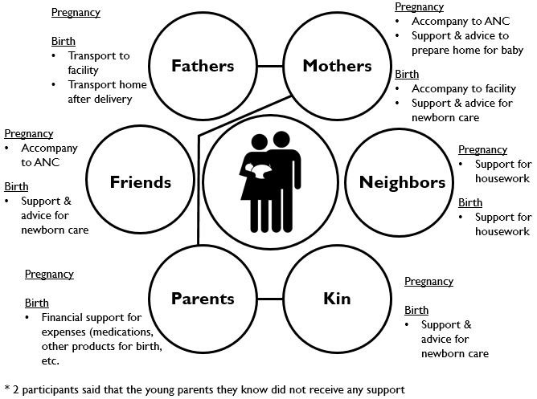
Figure 3: Example completed influence map from focus group discussions with family and kin

- In your experience, who in the family helps young unmarried mothers during their pregnancy and preparing for delivery? How do they help?

Use of Services
- Would you recommend that young parents in this community use health services for ANC, deliveries, and newborn care in public health facilities? What about private clinics? Why?
- Would you recommend that young parents use services of TBAs in this community? Why?
- What about use of modern FP methods? Would you recommend these services for young couples? Why?

Thank you!

Pregnancy | Pregnancy
Birth | Birth
Postpartum | Postpartum  Mother  Kin  Parents  Father

Pregnancy | Pregnancy
Birth | Birth
Postpartum | Postpartum

